**TIC PROJECT**

**(Word Part)**

**INTRODUCTION:**

**Information and Communications Technology (ICT *Or TIC in French*)** is an extensional term for information technology (IT) that stresses the role of unified communications and the integration of telecommunications (telephone lines and wireless signals)and computers, as well as necessary enterprise software, middleware, storage and audiovisual, that enable users to access, store, transmit, understand and manipulate information. ([wikipedia](https://en.wikipedia.org/wiki/Information_and_communications_technology), 2023)

**The Importance Of TIC (ICT):**



**Information and Communication Technology** can contribute to universal access to education, equity in education, the delivery of quality learning and teaching, teachers professional development and more efficient education management, governance, and administration.

**It has a huge role in early and modern technology like**:

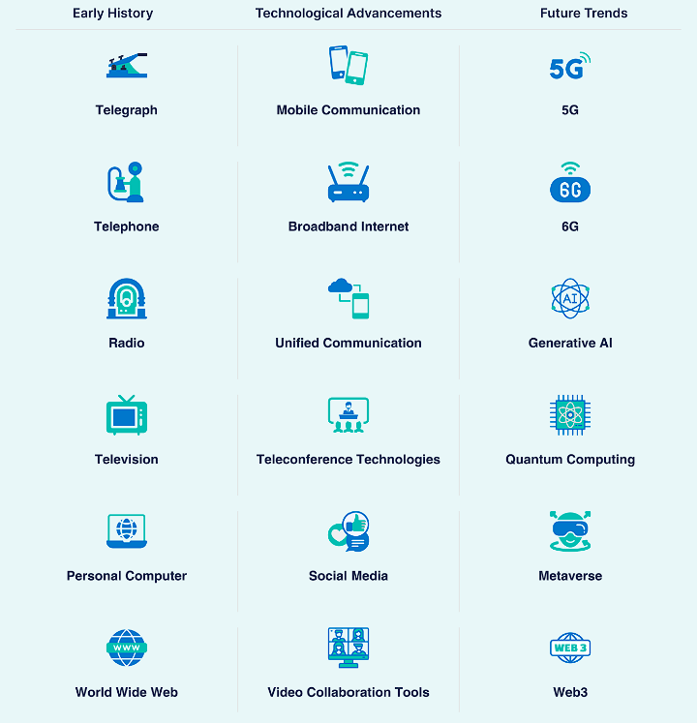

**Why we learn ICT (TIC) :  
Learning Information and Communication Technology (ICT) provides numerous benefits, including:**

1. Job Opportunities:

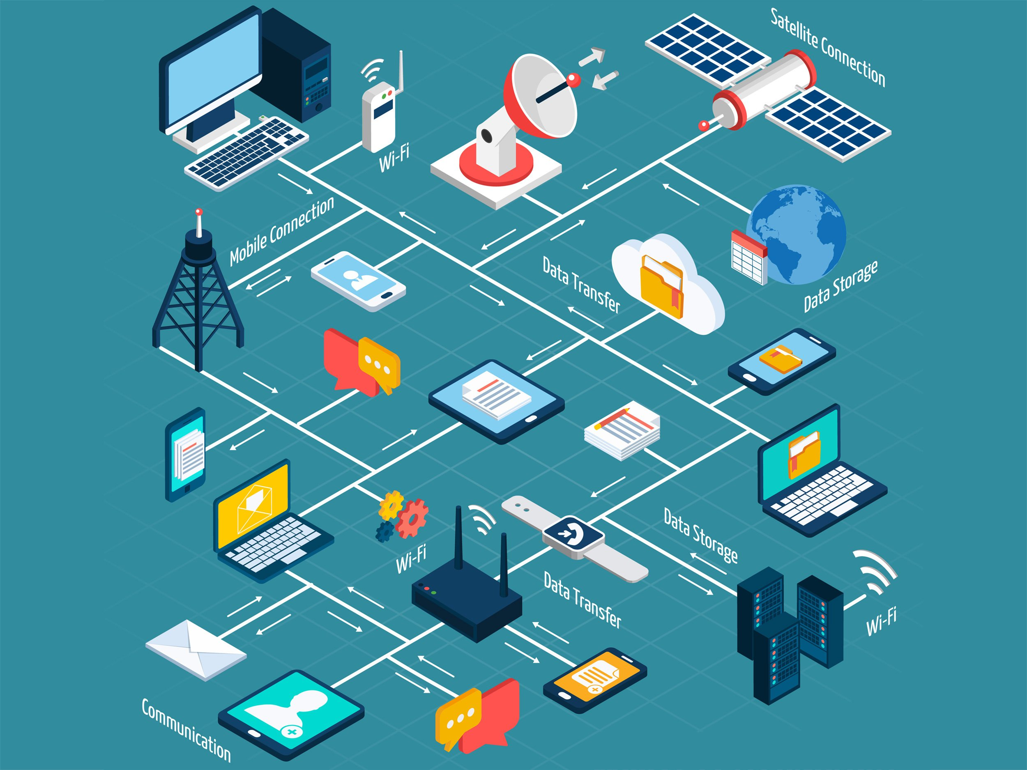

- Offers access to a wide range of employment opportunities in the technology sector.

2. Personal Skill Development:

- Contributes to the development of problem-solving, analytical thinking, and innovation skills.

3. Facilitates Learning and Research:

- Provides easy access to information and educational resources online.

4. Social Interaction:

- Enables the use of social media and online communication, enhancing social interaction.



5. Productivity Improvement:

- Can contribute to improving personal and organizational productivity.

6. Innovation and Entrepreneurship:

- Encourages creative thinking and innovation in finding solutions to challenges and developing new projects.

7. Broadening Learning Horizons:

- Expands opportunities for distance learning and interactive education.

8. Enhanced Understanding of Technology:

- Provides a better understanding of technology and how to effectively use it, fostering interaction with technological tools.

9. Self-Employment and Personal Projects:

- Enables the ability to create personal projects or work as a freelancer in the field of information technology.

10. Understanding Security and Data Protection:

- Enhances understanding of information security and the protection of personal data.

**In general**, **Information and Communication Technology** is an integral part of our daily lives, offering numerous opportunities to improve both personal and professional skills.

**Technologies Related To ICT (TIC):**

The world of **Information and Communication Technology (ICT)** is vast and diverse, encompassing numerous vital domains and advanced technologies. In this context, the domains of ICT can be categorized into several main branches. This world ranges from software development, information security, network technology, artificial intelligence, data analytics, graphic design, system interaction, cloud computing, and other exciting fields. This diversity provides opportunities for specialization in a specific area or continuous exploration of innovations and technological advancements.



**So we will mention some of these Technologies right here :**

**1.1 Git And GitHub :**

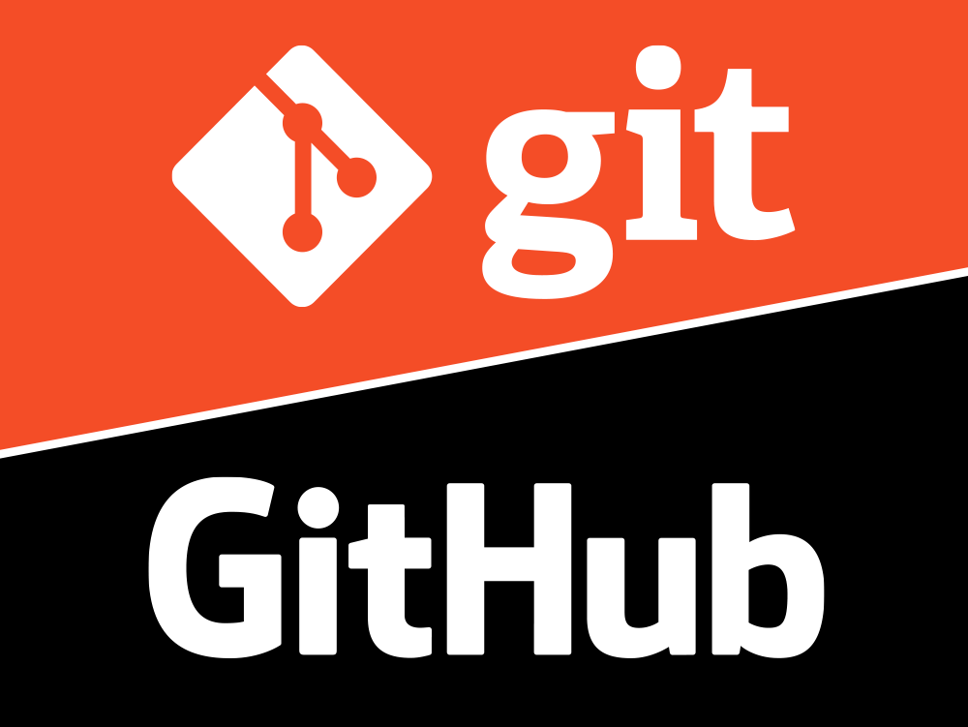

**Git** **is a distributed version control system that tracks changes in any set of computer files**, usually used for coordinating work among programmers who are collaboratively developing source code during software development, and support for distributed, non-linear workflows (thousands of parallel branches running on different computers). (Git, 2024)

**GitHub** is a web hosting platform used to manage **Git** projects and facilitate collaboration among developers.

**Git** offers several benefits for development teams and individual developers, including:

**1. Change Tracking:**

- **Git** records changes made to files, making it easy to understand the project's evolution over time,Git creates copies of the project (branches) for experimenting with new changes without affecting the main version.

**2. Effective Collaboration:**

- **Git** enables efficient collaboration among developers, allowing them to share the same project and easily integrate their change.

**3. Quick Retrieval:**

- **Git** provides efficient means to revert to a previous version in case of issues or errors.

**4. Security:**

- **Git** is a distributed system, meaning you have a local copy of your project, enhancing its resilience against data loss.

**5. Flexibility of Work:**

- **Git** allows developers to work effectively in multiple environments, even when offline.

Using **Git** significantly improves project management in development and creates an efficient working environment for developers.

**1.2 How We Use Git :**

Using **Git** involves a set of basic steps for managing change tracking and collaboration in a development project. Here are simple steps for using Git:

**1. Install Git:**

* Make sure **Git** is installed on your computer. You can download Git from the official website: [Git Downloads](https://git-scm.com/downloads).

**2. Creat a Git Repository:**

* Create a **Git** repository for your project. You can do this using the command:

git init

**3. Add Files for Tracking:**

* Use the **Git** add command to add files to the staging area, indicating their readiness for tracking changes.

git add <file1> <file2>…

**4. Commit Changes:**

* After adding files, use the **Git** commit command to commit and document the changes.

Git commit -m “ Commit message”

**5. Create and Switch Between Branchese:**

* Use the **Git** branch command to create and switch between branches.

git branch <branch-name>

git checkout<branch-name>

**6. Merge Changes:**

* Use the **Git** merge command to merge changes from one branch into the main branch.

git merge <branch-name>

**7. Restore Changes:**

* If needed, revert to a previous version using **Git** revert or **Git** reset.

**8. Update and Retrieve from Remote Repository:**

* If working with an online repository (e.g GitHub), use **Git** pull and **Git** push commands to update your project and share changes.

These are some basic steps for using **Git**. There are additional commands and scenarios based on your project needs and individual workflow.

**2) Microsoft Tools :**

**2.1 Microsoft Office :**

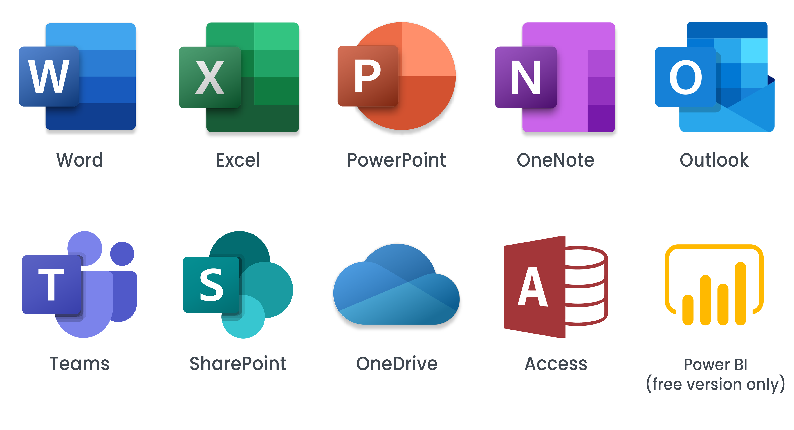

**It contain a lot of tools, but the most important are:**

**1. Microsoft Word:**



* **Microsoft Word** is a word processing program that allows users to create and edit text documents, used for multiple purposes : Education, Work …..

**2. Microsoft Excel:**



* **Microsoft Excel** is a spreadsheet that enables users to perform numerical calculations, create tables, and coduct data analysis, making it useful for financial operations and statistics.

**3. Microsoft Power Point:**



* **Microsoft PowerPoint** is a program for preparing and presenting slideshows, allowing the creation of advanced slides containing text, images, and graphics to illustrate ideas and informations.

**2.2 Visual Studio :**



**Visual Studio**

**Visual Studio** is an integrated development environment (IDE) provided by Microsoft, used for developing software applications on various platforms. Visual Studio offers a wide range of tools and services that assist developers in writing and debugging code, managing projects, testing applications, and deploying them.

Like **Visual Studio Code** Software:



It supports multiple programming languages, including C#, C++, Visual Basic, and others, and facilitates the development of various applications such as desktop applications, web applications, mobile applications, and cloud applications. The integrated environment and powerful features of Visual Studio enable developers to achieve higher efficiency in the development process and accelerate productivity.

**3) Overleaf(LaTeX) :**



**Overleaf**  is a collaborative cloud-based LaTeX editor used for writing, edititng and publishing scientific documents. It partners with a wide range of scientific publishers to provide journal LaTeX templates, and direct submission links.

**4) Google Services in IT:**

**In the following table we have the most important services that Google support:**

|  |  |  |  |
| --- | --- | --- | --- |
| **1** | **Google Docs** | Google Docs is an online word processor included as part of the free, web-based Google Docs Editors suite offered by Google. |  |
| **2** | **Google Sheets** | Google sheets is a spreadsheet application included as part of the free, web-based Google Docs Editors suite offered by Google | File:Google Sheets logo (2014-2020).svg - Wikipedia |
| **3** | **Google Slides** | Google Slides is a presentation program included as part of the free, web-based Google Docs suite offered by Google. |  |
| **4** | **Google Sites** | Google Sites is a structured wiki and web page creation tool included as part of the free, web-based Google Docs Editors suite offered by Google |  |

|  |  |  |  |
| --- | --- | --- | --- |
| **5** | **Google Cloud Storage** | Google Cloud Storage is a RESTful online file storage web service for storing and accessing data on Google cloud Platform infrastrucure. |  |
| **6** | **Google Meet** | Google Meet is a video communication service developed by Google. Used in hangouts, huge meetings,…. And ore |  |
| **7** | **Gmail** | Gmail is an email service provided by Google. As of 2019, it had 1,5 billion active users worldwide, making it the largest email service in the world. It also provides a webmail interface, accessible through a web browser, and is also accessible through the official mobile App. |  |
| **8** | **Google Drive** | Google Drive is a file storage ans synchronization service developed by Google. Launched on April 24,2012, Google Drive allows users to store files in the cloud, synchronize files across devices, and share files. |  |

**Conclusion:**

**In conclusion**, this project represents a crucial turning point in understanding the concept of "Computer science(*informatique*)" and exploring the services provided by Google and Microsoft. By focusing on Google Cloud Platform, Microsoft Tools, and version control tools like Git, along with the collaborative platform GitHub, the project illustrated how these technologies can enhance the efficiency and effectiveness of technological processes.



Thus, the project concludes with a comprehensive understanding of the technological services offered by Google and Microsoft, including Git and GitHub tools, contributing to the enhancement of technical capabilities and fostering innovation in the workplace context.

**Thanks For your attention**

